Terms:  
Measurable Viable Product (MVP)

A name for a product with the highest return on investment versus risk. A product that has just those core features that allow the product to be deployed and no more. It may be used by early adopters because they are more forgiving and will give feedback.

Lean UX Design Process  
Based on Agile and it’s a way to design applications with just enough features to see if it works. Outcome is a MVP.

# Prototyping Steps:

# Kick Off

## Discuss and Agree on Foundation Objectives

### What are the most important design problems? Problems may be big like designing a product for the first time, or big redesign, or new features. Or it might be something more detailed, like improving a single action. Overall, it has to be really important to the company.

### Agree on the requirements

### Rate Objective and Requirements according to priority, completeness and expected complexity. Covers the entire project.

### Select the Prototype lead. Ideally teams would be self-organizing, but one person should be picked to facilitate meetings. This could be the Scrum Master.

## Get the Right People

### Designers

### Product Owner

### User Expert

### Programmers

## Recruit Users for testing

Find any number of users who will test the design solution on the last day of the sprint.

### Schedule Users for last day of sprint

## What design tools do we need

### Sticky Notes

### Paper, Pens

### Whiteboard

### Template printouts

### Prototyping Software

# Early Requirements Gathering

## Prototype lead talks to stakeholders

### Extract information about the objectives with stakeholders.

## Create user stories

## Follow “How Might We” (HMW).

Example: “How might we create a more refreshing soap…” Also, the Why?

# Sketch Detailed Solutions

Team works quietly (no brainstorming session) to come up with ideas on paper. Everyone can contribute, nobody gets too attached to the idea, and done fast

### Take a story

Choose a story you would like to sketch.

### Easy Sketching

Get paper, pencils/pens, printed templates of phones, tablets, and screen size. Sketch out details on paper. Avoid High fidelity.

### Sample Workflow

#### Notes

Read your notes and review previous steps to clarify what you’re working on.

#### Mind Map http://a.fastcompany.net/multisite_files/codesign/imagecache/inline-large/inline/2013/06/1672917-inline-mindmap.jpg

#### Sketching using Crazy 8z / Templates http://g.fastcompany.net/multisite_files/codesign/imagecache/inline-large/inline/2013/06/1672917-inline-crazy8s.jpg

#### Storyboard

Sketch how a user would move through the part of the story.  
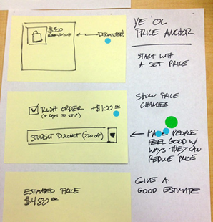

### Silent critique

Team members place their ideas out for everyone to view. The look at all the ideas, and choose the ideas they like. This could be done with stickers, paper, etc.

### Critique

Everyone gathers around each storyboard at a time and talk about what they liked, ask questions to the person who drew it.

### Vote

Team votes on which features to keep. Basically, identify the strongest concepts. When voting each team member has votes. Team members with have more votes.

# Decide on Features

Choose the features you want to pursue

### Wireframe

Create a more high-fidelity version using software tools.

#### UXpin

#### LucidChart

#### Illustrator / Photoshop

**[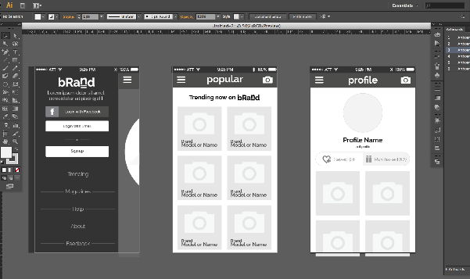](http://fakecrow.com/wp-content/uploads/2013/12/wireframes_illustrator.png)**

### Style Guide?

# Prototype Building

## Software

### Adobe Edge Reflow

### UXPin

### LucidChart

### MarvelApp

# Test

## Show the prototype to user testers.

### Determine what you want to accomplish

### Determine flaws

## Get ready for next sprint